Measles epidemiology and control impact in Saudi Arabia over ten years.
Before the era of vaccine measles epidemiology involved virus spread among the susceptible population, reducing its susceptibility rate to 3.0% to 7.0% and subsequently maintaining of as high as 93 to 97% herd immunity that is further maintained by consistently circulating wild measles virus(1). Vaccination became the main means of achieving high level of herd immunity without having to pay the price of high mortality and morbidity. The current estimate is that measles vaccination averted over 60 million global deaths between 2000 and 2023(2) reducing the number of cases from 36,940,000 in 2000 to 10,341,000 and the annual number of measles deaths from 800,000 in 2000 to 107,500 in 2023(2). However, measles remains a major killer leading to 107,500 deaths due to lack of vaccination or low vaccination coverage age of below 5 years of age(2) as vaccination coverage of ≥95% with two doses of measles containing vaccine is required to consistently maintain high level of herd immunity and efficiently control measles and prevent outbreaks(3–5). In communities with low vaccination coverage and subsequently low herd immunity measles resurge due to the high measles contagiousness with a basic reproduction number (R₀) often between 12 and 18(6). The under 5 children population among whom malnourishment prevail measles deaths occur because of its complications including pneumonia diarrhea, otitis media, and encephalitis(7).
The measles virus is a single stranded RNA helical enveloped virus that belongs to the family paramyxoviridae, genus morbillivirus with a single serotype and human as the only host [8]. The virus infects the lungs alveolar macrophages and dendritic cells through haemagglutinin protein on its surface and fuses with the plasma membrane through fusion protein leading to systemic spread of the virus with primary and secondary viraemia(1).
In Saudi Arabia since introduction of measles vaccine 1974 through annual campaigns that targeted 1-9 years old children(8). In 1982 Shwartz vaccine was first introduced to immunize 9 months infants with initially a low vaccination coverage that increased over the 1980s to exceed 90% 1990 using(8). Then in 1991 a two-dose policy was introduced which comprised one dose of the more immunogenic Edmonston Zagreb vaccine at 6-month and one dose of MMR vaccine at 12 months to reduce the number of measles cases in the community at large and among those of less than five years old children; to eliminate or reduce measles occurring at 6 and 9 months, which accounts for about 50% of cases below the age of one year based on the ministry of health report(9). As of 2001 the schedule was modified to two doses of the MMR vaccine: the first at 12 months and the second at 6 years of age(9). This is a retrospective descriptive study conducted to analyze the trend, distribution and impact of control of measles in Saudi Arabia in a period between the year 2014 to 2023. Moreover, the study aimed to describe national epidemiological patterns rather than establish causal associations.
Methodology

This descriptive epidemiological study analyzed the absolute number of reported measles cases, crude incidence rates (CIRs), average annual incidence rates (AAIRs), and temporal trends in Saudi Arabia during 2014–2023. Data were obtained from the annual statistical yearbooks published by the Saudi Ministry of Health (MOH) and population estimates provided by the General Authority for Statistics (GASTAT)(10). The MOH yearbooks provided longitudinal national surveillance data on vaccine-preventable diseases, including measles cases that were either laboratory-confirmed or clinically diagnosed. National and regional population estimates were obtained from GASTAT, whereas age-specific population estimates were derived from the United Nations World Population Prospects 2024(11).

Regional measles incidence was assessed across the 20 health regions of Saudi Arabia during 2014–2023, using the corresponding annual regional population estimates as denominators. The average annual incidence rate (AAIR) for each health region and age group was calculated by dividing the total number of measles cases reported in the respective health region or age group during 2014–2023 by the sum of the corresponding annual population estimates over the same period and multiplying by 100,000. The AAIR was expressed as the average number of reported measles cases per 100,000 population per year for each health region or age group.

Results
During the period from 2104 to 2016, the number of cases was relatively low and steady. The number of cases steadily increases after words to peak in the years 2018. This was followed by slight decline in the number of cases during the year 2019 and a sharp decline in the year 2020. There was a rebound in the number of cases starting in the year 2021 with a modest decrease in the year 2022 followed by a major surge in the year 2023 (Figure 1).

Figure 1a : Cases of measles reported over 10 years from 2014 to 2013 (2-14-2023)

Age-specific measles incidence rates varied considerably during 2014–2023, with marked increases during the outbreak years of 2018, 2019, and 2023 (Figure 2a). Despite these fluctuations, a consistent age-related gradient was observed, with incidence decreasing progressively with increasing age. Over the 10-year study period, the highest average annual incidence rate (AAIR) was recorded among infants aged <1 year, followed by children aged 1–<5 years, 5–<15 years, and individuals aged 15–<45 years with lowest AAIR was observed among individuals aged ≥45 years (Figure 2b). Annual incidence peaked in 2023, among infants and children aged 1–<5 years, respectively, whereas incidence declined markedly across all age groups in 2020 (Figure 2b). Differences in annual age-specific incidence rates across the five age groups were statistically significant (Friedman χ²(4) = 39.82, p < 0.001).

Figure 2a: Annual age-specific incidence rates of reported measles cases in Saudi Arabia, 2014–2023.
Year | <1 | 1–<5 | 5–<15 | 15–<45 | ≥45
2014 | 5.78 | 2.52 | 0.56 | 0.2 | 0.11
2015 | 11.28 | 3.29 | 0.45 | 0.31 | 0.11
2016 | 5.66 | 1.91 | 0.33 | 0.16 | 0.1
2017 | 27.9 | 5.83 | 1.19 | 0.51 | 0.25
2018 | 61.14 | 19.28 | 3.8 | 0.98 | 0.11
2019 | 71.17 | 17.41 | 2.42 | 0.56 | 0.21
2020 | 0.74 | 0.63 | 0.23 | 0.02 | 0
2021 | 18.31 | 5.56 | 0.48 | 0.48 | 0.04
2022 | 9.84 | 4.16 | 0.75 | 0.37 | 0.03
2023 | 107.23 | 43.83 | 10.46 | 0.97 | 0.43
* Values represent reported measles cases per 100,000 population within each age group and year.
* Darker shading indicates higher age-specific incidence rates

Figure 2b: Average annual incidence rate of measles by age group, Saudi Arabia, 2014–2023

The aggregated monthly distribution of measles cases during 2014–2023 showed the highest case numbers in March, followed by February and April, with a general decline toward the later months of the year (Figure 3a). However, the year-by-month heatmap (Figure 3b) demonstrated substantial temporal heterogeneity, with the timing of peak case numbers varying considerably between years. Thus, the apparent concentration of cases during the early months of the year was not consistently reproduced across individual years and appeared to be influenced by the timing and magnitude of individual outbreaks. Analysis of the 120 monthly observations using the Friedman test showed no statistically significant difference in monthly case distribution across the study period (χ² = 10.11, df = 11, p = 0.520), providing no evidence of a consistent seasonal pattern.

Figure 3a: aggregated monthly distribution of case documented over 10 years (2014-2023)

Figure 3b. Year-by-month distribution of reported measles cases in Saudi Arabia, 2014–2023.
Year | Jan | Feb. | Mar. | Apr. | May | June | July | Aug. | Sep. | Oct. | Nov. | Dec.
2014 | 17 | 20 | 17 | 18 | 16 | 10 | 4 | 7 | 5 | 13 | 13 | 14
2015 | 20 | 6 | 4 | 38 | 54 | 51 | 17 | 15 | 5 | 5 | 4 | 0
2016 | 4 | 9 | 8 | 4 | 7 | 6 | 19 | 23 | 6 | 12 | 9 | 18
2017 | 82 | 84 | 39 | 26 | 17 | 8 | 17 | 13 | 28 | 27 | 53 | 63
2018 | 73 | 105 | 185 | 251 | 169 | 73 | 69 | 34 | 39 | 52 | 51 | 55
2019 | 292 | 424 | 157 | 62 | 19 | 26 | 14 | 13 | 1 | 3 | 12 | 1
2020 | 5 | 8 | 12 | 7 | 1 | 0 | 0 | 0 | 0 | 0 | 0 | 1
2021 | 0 | 1 | 2 | 0 | 3 | 3 | 1 | 1 | 67 | 123 | 96 | 30
2022 | 18 | 3 | 6 | 1 | 10 | 33 | 15 | 39 | 40 | 20 | 27 | 35
2023 | 110 | 161 | 400 | 351 | 372 | 243 | 191 | 152 | 96 | 71 | 47 | 60

.

During 2014–2023, the overall average annual incidence rate (AAIR) of reported measles was 1.83 cases per 100,000 population per year. Considerable geographic variation was observed, with the highest AAIRs in Qurayyat (17.97 per 100,000/year), Al-Jouf (15.97), and Najran (10.21), compared with 0.35 per 100,000/year in Al-Bahah. Thus, the long-term average rate in Qurayyat was approximately 9.8 times the overall rate and 51 times that observed in Al-Bahah (Figure 4).

Figure 4: Average annual measles incidence by health region Saudi Arabia, 2014 -2023 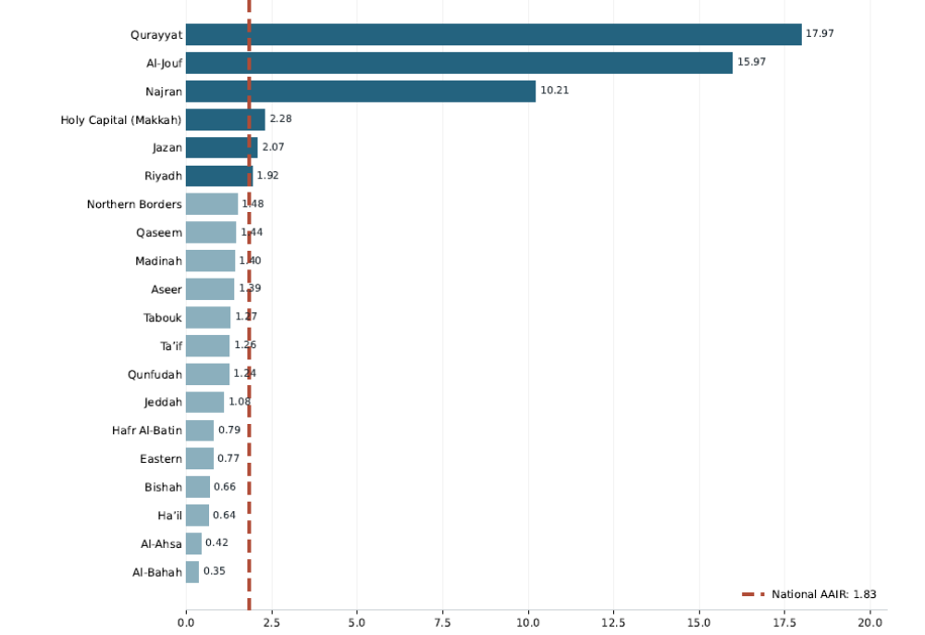
National AAIR = 1.83
Reported measles cases per 100,000 population per year
National AAIR = 5,997 cases ÷ (32,694,320 mean annual population × 10 years) × 100,000 = 1.83/100,000 population/year

Discussion
The year -to- year fluctuation in reported cases is consistent with nature of the measles epidemiology. In this the annual number of cases vary with level of accumulation of susceptible individuals. Cases accumulate when herd immunity declines below 95%. This pattern reflects the exceptionally high transmissibility of measles, with a conventionally estimated basic reproduction number (R₀) of 12–18, although considerable variation across epidemiological settings has been reported (12–14). The low reported cases during the period between 2014 to 2016 suggests limited transmission during these years and reflect the high vaccination coverage which reached 96%(10) that resulted in maintaining high herd immunity and limited importation of cases or effective containment. This is inconsistent with post-elimination age where measles spread is low level but not entirely interrupted. The resurgence of cases during the period between 2017-2019 may despite high vaccination coverage reflect imported cases likely due to international traveler reduction of herd immunity albite at low level. Accumulation of susceptible individuals could occur because of missed vaccination doses of vaccine hesitancy due to likely reduced perception of measles severity among public. Suboptimal coverage of the second dose of measles-containing vaccine could also be the reason. Epidemiologically this could give rise to failure to sustain optimum level of herd immunity which may cause an explosives spread of the measles given the high R₀. Most of the cases reported during years 2017 to 2019 were of the age group of below 1 year to over 5 years. This reflects low herd immunity among these age groups which could be caused by first and second doses suboptimal coverage or delayed vaccination.
Majority of cases were of the age below 1 year up to 15 years particularly children under five years of age. This is consistent with the global finding indicating substantial measles burden in young children(12–15).This pattern is epidemiologically expected and reflects both early-life susceptibility prior to full vaccination and high transmission in preschool and school-age children. The lower number of cases among adults is attributable to immunity due to vaccination or prior infection.
Infants aged below one year showed the highest AAIR suggesting high susceptibility to measles due to waning maternal antibody levels before an adequate vaccination- induced protection. Previous studies have reported age-specific AAIR of 6.7 and 35.8 (16,17) cases per 100,000 infants although differences in study periods, outbreak intensity, and surveillance practices should be considered when interpreting these comparisons. In comparison, the incidence observed in the present study (up to ~74 per 100,000) indicates a relatively higher transmission intensity specially as this rate recorded at the year of 2023 which followed the COVID-19 closedown during which susceptible cases have accumulated as a result of social distancing lowering the intensity of transmission and therefore the maximizing the susceptibility.

It indicates a relatively higher transmission intensity, especially as this rate recorded at the year of 2023 which followed the COVID-19 closedown during which susceptible cases have accumulated as a result of social distancing lowering the intensity of transmission and therefore maximizing the susceptibility. This early susceptibility is likely to be impacted by the lower and rapidly waning maternal antibody levels associated with vaccine- induces immunity and the ongoing community transmission owing to immunity gaps. Additionally, the presence of measles cases among adults of reproductive age suggests residual susceptibility in this group, which may contribute to reduced levels of maternally derived antibodies in infants. However, this factor alone is unlikely to fully explain the observed burden of disease in infants.
The other possible reason for the high reported burden of measles among those below 1 years is vaccine failure in which maternal antibodies neutralize the vaccine antigen. The sharp decline in reported cases during the year 2020 likely reflects the COVID-19 related non-pharmaceutical intervention, mainly social distancing. This is consistent with epidemiology of measles, a highly contagious viral infection whose transmission is significantly reduced by measures that restrained by close interpersonal contact.

Discussion of above data
The pattern of transmission over 10 years clearly demonstrates seasonality of measles. High transmission rate started in early winter peaking in late winter and early spring where overcrowding and interpersonal close contact is highest allowing maximum spread of the virus. With lowest transmission occurring in early autumn with slight increase thereafter coinciding with school
The annual distribution of measles cases over 10 years number

Immunization strategies are based on these principles. Achieving high vaccination coverage helps maintain a high level of herd immunity, which further reduces viral circulation within the population. This, in turn, limits natural exposure to the wild virus, thereby reducing opportunities for natural boosting of immunity.

Additionally, the continued accumulation of susceptible children—due to early loss of maternal antibodies and primary or secondary vaccine failure—can increase the risk of future outbreaks.
1. CDC. Epidemiology and Prevention of Vaccine-Preventable Diseases [Internet]. 2024 [cited 2026 Mar 21]. Chapter 13: Measles. Available from: https://www.cdc.gov/pinkbook/hcp/table-of-contents/chapter-13-measles.html
2. Minta AA, Ferrari M, Antoni S, Lambert B, Sayi TS, Hsu CH, et al. Progress Toward Measles Elimination — Worldwide, 2000–2023. MMWR Morb Mortal Wkly Rep. 2024 Nov 14;73(45):1036–42. doi:10.15585/mmwr.mm7345a4 PubMed PMID: 39541251; PubMed Central PMCID: PMC11576049.
3. Plans-Rubió P. Measles Vaccination Coverage and Anti-Measles Herd Immunity Levels in the World and WHO Regions Worsened from 2019 to 2023. Vaccines (Basel). 2025 Feb 5;13(2):157. doi:10.3390/vaccines13020157 PubMed PMID: 40006704; PubMed Central PMCID: PMC11860562.
4. Plans-Rubió P. Vaccination Coverage for Routine Vaccines and Herd Immunity Levels against Measles and Pertussis in the World in 2019. Vaccines. 2021 Mar;9(3):256. doi:10.3390/vaccines9030256
5. Nearly 40 million children are dangerously susceptible to growing measles threat [Internet]. [cited 2026 Mar 21]. Available from: https://www.who.int/news/item/23-11-2022-nearly-40-million-children-are-dangerously-susceptible-to-growing-measles-threat
6. Guerra FM, Bolotin S, Lim G, Heffernan J, Deeks SL, Li Y, et al. The basic reproduction number (R0) of measles: a systematic review. Lancet Infect Dis. 2017 Dec;17(12):e420–8. doi:10.1016/S1473-3099(17)30307-9 PubMed PMID: 28757186.
7. Hübschen JM, Gouandjika-Vasilache I, Dina J. Measles. Lancet. 2022 Feb 12;399(10325):678–90. doi:10.1016/S0140-6736(21)02004-3 PubMed PMID: 35093206.
8. al-Mazrou YY, al-Jeffri M, Ahmed OM, Aziz KM, Mishkas AH. Measles immunization: early two-doses policy experience. J Trop Pediatr. 1999 Apr;45(2):98–104. doi:10.1093/tropej/45.2.98 PubMed PMID: 10341504.
9. Khalil MK, Al-Mazrou YY, Al-Jeffri M, Al-Ghamdy YS. Measles immunization in Saudi Arabia: the need for change. East Mediterr Health J. 2001;7(4–5):829–34. PubMed PMID: 15332786.
10. Statistical Yearbook - Statistical Yearbook [Internet]. [cited 2025 Oct 9]. Available from: https://www.moh.gov.sa/en/Ministry/Statistics/book/Pages/default.aspx
11. World Population Prospects [Internet]. [cited 2026 Sep 6]. Available from: https://population.un.org/wpp/downloads?folder=Standard%20Projections&group=Most%20used
12. Mishra A, Mishra S, Lahariya C, Jain P, Bhadoriya RS, Shrivastav D, et al. Practical Observations from an Epidemiological Investigation of a Measles Outbreak in a District of India. Indian J Community Med. 2009 Apr;34(2):117–21. doi:10.4103/0970-0218.51234 PubMed PMID: 19966957; PubMed Central PMCID: PMC2781117.
13. Measles cases rise in the Americas in 2025 - PAHO/WHO | Pan American Health Organization [Internet]. 2025 [cited 2026 Mar 21]. Available from: https://www.paho.org/en/news/3-7-2025-measles-cases-rise-americas-2025
14. Measles [Internet]. [cited 2026 Mar 21]. Available from: https://www.who.int/news-room/fact-sheets/detail/measles
15. Wang R, Jing W, Liu M, Liu J. Trends of the Global, Regional, and National Incidence of Measles, Vaccine Coverage, and Risk Factors in 204 Countries From 1990 to 2019. Front Med (Lausanne). 2022 Jan 20;8:798031. doi:10.3389/fmed.2021.798031 PubMed PMID: 35127753; PubMed Central PMCID: PMC8810814.
16. Harris C, Bird C, Saavedra-Campos M, Chatt C, Booth E, Proto W, et al. Impact of a measles outbreak on a UK children’s emergency department and the public health response: a retrospective observational study. Journal of Hospital Infection. 2025 Nov 1;165:41–7. doi:10.1016/j.jhin.2025.07.020
17. GOV.UK [Internet]. [cited 2026 Mar 24]. Confirmed cases of measles in England by month, age, region and upper tier local authority: 2026. Available from: https://www.gov.uk/government/publications/measles-epidemiology-2023/confirmed-cases-of-measles-in-england-by-month-age-region-and-upper-tier-local-authority-2026
2025: 35.8 in 2024;9 in 2023/2024 6.7
References to be added to zetero list
• UKHSA epidemiology report 2024
https://www.gov.uk/government/publications/measles-epidemiology-2023
• UKHSA dashboard (age distribution)
https://ukhsa-dashboard.data.gov.uk
• BMJ / UK outbreak context
https://www.bmj.com/content/385/bmj.q972

